11a. CNN ON MNIST DATASET

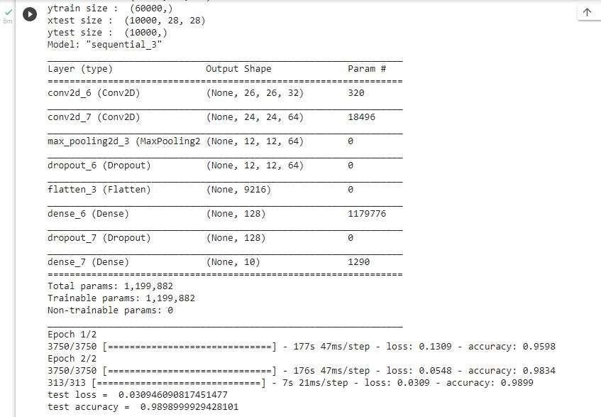

11b. CNN WITH BATCH NORMALISATION AND CALLBACKS ON MNIST DATASET

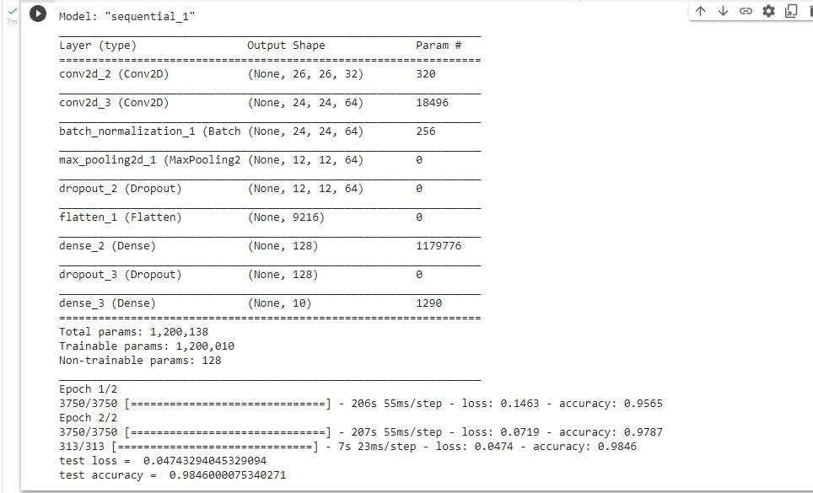

11c. CNN ON FASHION MNIST DATASET

